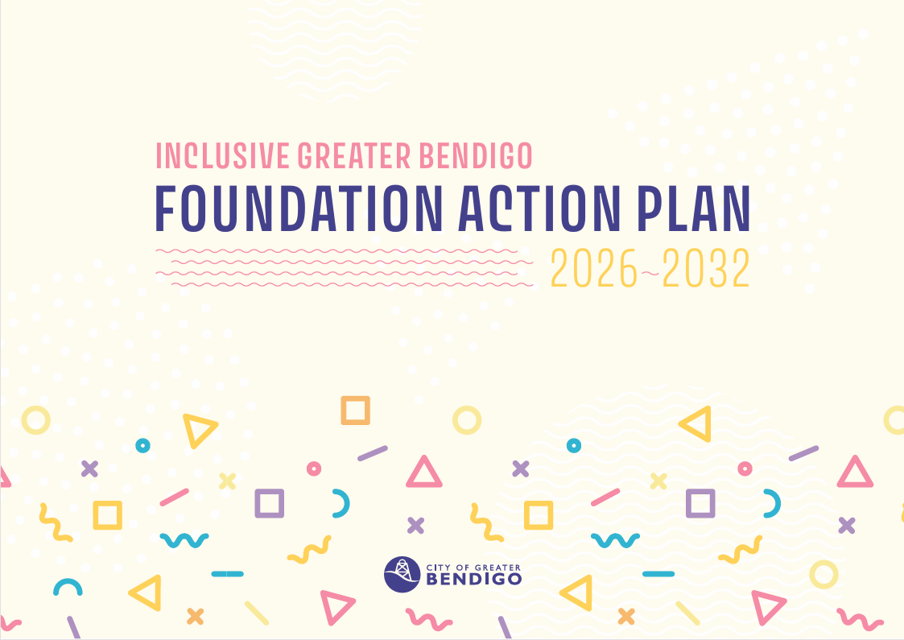

Community Vision
Greater Bendigo celebrates and respects our diverse and growing community. We aim to be welcoming, sustainable and flourishing. Walking hand-in-hand with our First Nations communities. Building on our heritage for a safe and happy future.

From strategy to action
The Inclusive Greater Bendigo Strategy explains what kind of community we want to be.
The Action Plan explains what we will actually do over the next two years to make this happen.
The Strategy stays the same over time. The Action Plan is updated every two years.

Our actions
The Action Plan includes two different types of action.
Both are important, and they work best together.

Transformative actions – Better decisions for more people
Transformative actions focus on improving how decisions are made so they work for more people from the start.
They align with the Inclusive Greater Bendigo priority of Better decisions for more people by changing systems and practices to reduce exclusion before it happens.
They focus on things like:
- how decisions are made
- how services are designed
- how information is shared
These actions often help many people at once, including people who face exclusion for different reasons at different times.

Targeted actions – Everyday life that feels safe, fair and welcoming
Targeted actions focus on improving everyday experiences for people who face ongoing and unfair barriers more often.
They align with the Inclusive Greater Bendigo priority of Everyday life that feels safe, fair and welcoming by addressing specific barriers and supporting inclusion in community life.
They focus on:
- seeking input from people with different life experiences and circumstances
- improving everyday access and safety
- making sure voices are heard and respected
Targeted actions sit alongside transformative actions, not instead of them.

The Action Plan is not everything the City does
The Action Plan does not list everything the City does to support inclusion.
Many inclusive practices are already part of everyday work. These things continue whether they appear in the Action Plan or not.
The Action Plan focuses on:
- new or priority actions,
- areas where change is still needed, and
- work that helps improve systems over time.
This helps keep the Action Plan clear, focused and achievable, while inclusion continues across all areas of the City’s work.

Foundation Actions (Transformative)
 | Name | Pillar | Action | Measure
 | Transformative – Reconciliation | All | Embed reconciliation, self-determination and respect for Country into how the City plans, makes decisions and works every day, by delivering and implementing Barpangu 2026–2030 (Build Together) in partnership with Traditional Owners and First Nations people. | Barpangu delivered and implementation commenced.
 | Transformative – Better decisions for more people | All | Transform decision-making across the City so programs, policies and services better reflect diverse lived experience and reduce unintended exclusion. | Uplift of Equity Impact Assessments across internal and external programs, policies and services.  Gender Equity Action Plan progress report.
 | Transformative – Building capability for inclusive practice | All | Transform how the City works by embedding inclusive practice into planning, decision-making, service design and delivery. | Staff capability in inclusive practice strengthened through training, tools and on‑the‑job support.  Inclusive practice guidance developed.  Scope Communications Access Symbol re-accreditation achieved.
 | Transformative – Grant funding as a lever for inclusion | All | Strengthen inclusion in community life by ensuring the City's grants programs support equitable, accessible and inclusive outcomes across diverse experiences, identities, places, life stages and life circumstances. | Community grants program reviewed and refreshed.  Evidence of funded projects supporting community participation, connection, accessibility, belonging or inclusion across Greater Bendigo.
 | Transformative – Early years collaboration and decision-making | All | Create a more connected and inclusive early years system by strengthening collaboration, coordination and shared leadership across organisations that support children and families. | Cross-sector child and family collaboration and governance group established.  Evidence of coordinated input informing early years planning, policies or initiatives.
 | Transformative – Partnerships and advocacy for inclusion | All | Strengthen inclusion across Greater Bendigo through strategic partnerships and advocacy that respond to changing community needs, life circumstances and local contexts, helping influence systems, services and policies beyond the City's direct control. | Strategic partnerships established, maintained or strengthened in response to priority inclusion issues, including homelessness, housing insecurity and place-based barriers to participation.  Evidence of collective advocacy on emerging community needs.  Examples of systems, service or policy changes influenced through partnership activity.
 | Transformative – Leadership in welcoming and inclusion | All | Build on the City and Council’s strong leadership in inclusion to support and influence other local governments in creating more welcoming and inclusive communities. | Welcoming Cities Excelling accreditation maintained and Mentoring status achieved.

Foundation Actions (Targeted)
 | Type | Pillar | Action | Measure
 | Targeted – Voice and influence for children | Lifespan | Strengthen opportunities for children to share their views and influence City decisions so children are listened to on issues that affect their everyday lives, and their perspectives help shape planning, services and places designed for them. | Children’s input informs selected City plans, strategies or projects.
 | Targeted – Youth voice, leadership and participation | Lifespan | Strengthen youth voice, leadership and participation by creating opportunities for young people to influence decisions, develop skills and build connections that support their involvement in community, civic and employment pathways. | Youth Council engaged in a range of City plans, projects and decisions, with input provided at an early stage.  Youth leadership or skills programs delivered or supported each year.  Young people participate in training, creative or community opportunities.
 | Targeted – Recognition and celebration of people across the lifespan | Lifespan | Strengthen recognition, participation and influence of children, young people and older adults through showcasing their talents, achievements and community contributions, while creating opportunities for people to connect across generations so that knowledge, lived experience and community strengths can be shared. | Recognition opportunities (e.g. awards, showcases, exhibitions or storytelling platforms) delivered or supported.
 | Targeted – Women in non-traditional roles | Life circumstances  Culture, identity, communication | Advance gender equity in employment across Greater Bendigo by strengthening networking, mentoring and peer support opportunities for women in non-traditional roles. | Women In Non-Traditional Roles (WINTR) Network supported and sustained.  Participant feedback demonstrates increased confidence, connection and access to professional support.
 | Targeted – Community capacity to prevent gender-based violence | Life circumstances  Culture, identity, communication | Strengthen community leadership, capacity and collective action to advance gender equality and prevent gender-based violence. | Community organisations supported through grants to deliver initiatives during 16 Days of Activism.
 | Targeted - Disability-inclusive decisions | Life circumstances  Culture, identity, communication | Strengthen how disability perspectives inform decision-making so policies, programs, places and services better reflect lived experience and are more accessible, inclusive and easier to use. | Evidence of strategies, plans and projects informed by disability perspectives at concept stage through the Disability Inclusion Reference Committee.
 | Targeted – Intercultural leadership, connection and participation | Culture, identity, communication | Strengthen intercultural leadership, connection and participation so people from diverse cultural and faith backgrounds are supported to contribute, influence and build belonging within the broader community. | Intercultural Ambassadors Program delivered.  Participants report increased leadership capability, confidence and connection.
 | Targeted - Multicultural and multifaith celebration | Culture, identity, communication | Strengthen the visibility, celebration and inclusion of multicultural and faith-diverse communities by supporting community-led opportunities for people to celebrate culture, faith and identity together with the wider Greater Bendigo community, fostering understanding, belonging and mutual respect. | Key community events and days of significance supported and celebrated and attended each year.
 | Targeted – LGBTIQA+ community capacity and visibility | Culture, identity and communication | Strengthen community capacity to lead and deliver events or initiatives that enhance the visibility, celebration and inclusion of LGBTIQA+ communities, so that LGBTIQA+ people and communities feel recognised, valued and welcome in Greater Bendigo. | Key LGBTIQA+ days of significance recognised each year.  Evidence of support for community-led events or initiatives.
 | Targeted – Safe, welcoming and inclusive spaces and places | All | Strengthen access to safe, welcoming and inclusive community spaces that meet changing needs and support participation, connection and belonging across diverse ages, identities, life circumstances and locations, recognising that experiences differ across neighbourhoods, townships and rural communities. | Community Infrastructure and Precincts Strategy implemented.  Young people report feeling safe and welcome at City‑supported youth spaces or events.  Early Years Infrastructure Framework updated.
 | Targeted – Safe, welcoming and inclusive events | All | Strengthen connection, participation and belonging across Greater Bendigo through safe, welcoming and inclusive community events and activities that bring people together across cultures, identities, ages, and life experiences. | Community-led events and activities supported each year.  City-led events celebrated and delivered each year.  Evidence of deliberate inclusion in event design and delivery.

