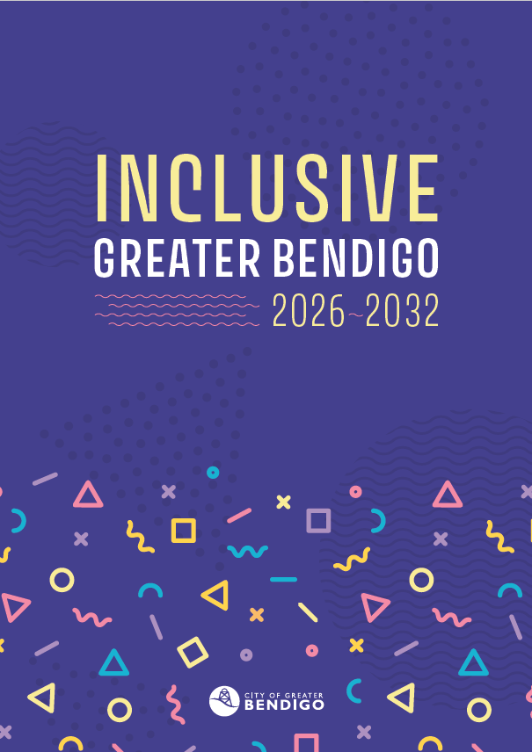

Summary – Inclusive Greater Bendigo
2026 – 2032

SUMMARY

How to read this summary
This summary is a short, accessible overview of the Inclusive Greater Bendigo Strategy, designed for people who want the key points quickly. It outlines the strategy’s purpose, priorities and how progress will be measured. More detailed background, rationale and implementation detail sit in the full strategy

Community Vision
Greater Bendigo celebrates and respects our diverse and growing community. We aim to be welcoming, sustainable and flourishing. Walking hand-in-hand with our First Nations communities. Building on our heritage for a safe and happy future.

Acknowledgement of Country
We acknowledge the Dja Dja Wurrung and Taungurung Peoples as the Traditional Owners of the land on which the City of Greater Bendigo stands.
We pay our respects to leaders and Elders past, present and future, who hold the memories, the traditions, the culture and the hopes of all Dja Dja Wurrung and Taungurung Peoples. We thank them for sharing this land, recognise the pain and loss caused by that sharing, and hope that we can walk forward together in harmony and in the spirit of healing.
We also pay our respects to all Aboriginal and Torres Strait Islander peoples living in Greater Bendigo.

Strategic priorities
Inclusive Greater Bendigo is guided by two long-term strategic priorities. They describe how the City will make decisions and what people should experience in everyday life in Greater Bendigo.

Priority 1: Better decisions for more people
This means making decisions that work for lots of different people – not just one ‘typical person’.
We do this by:
- seeking input from people with different life experiences
- thinking early about who might be left out
- changing how decisions are made, avoiding the need to fix problems later
Priority 1 success looks like:
Our decisions are made for many kinds of people, understanding that people experience things differently.

Priority 2: Everyday life that feels safe, fair and welcoming
This means improving what people experience in their everyday lives in Greater Bendigo.
This includes:
- using the City’s services and facilities
- getting information
- being in public spaces
- taking part in community life
Priority 2 success looks like:
Our services and public places are designed to be easy and safe for everyone to use. Different needs are planned for from the start. When people do need help, it is easy to ask for. The strengths of our diverse community are recognised, valued and celebrated.

What this strategy is about
Greater Bendigo is home to people with different backgrounds, abilities, ages, cultures, incomes, identities and life experiences. This diversity is a strength – but everyday life does not work equally well for everyone.
Many decisions are designed around a ‘typical person’, someone who:
- has flexible time
- speaks and reads English easily
- can travel without difficulty
- feels safe in public spaces
- has stable housing, health and income
- understands how local government works
When decisions, services and spaces are designed this way, some people are unintentionally left out.
This strategy is about changing that. We want Greater Bendigo to be a place where every life works for more people.
The strategy focuses on:
- how decisions are made, and
- how those decisions affect people in everyday life
This is not about labelling people or groups.
It is about recognising difference and designing for it from the start in ways that value and build on people’s strengths.
When decisions work for people with different lives and needs, they work better for everyone.

The strengths we start from
This is a strengths-based strategy. It focuses on what people and communities contribute, not what they lack.
Across Greater Bendigo, people contribute:
- care for family, friends and neighbours
- cultural knowledge, languages and traditions
- skills, creativity and leadership
- lived experience that helps identify better solutions
- strong local networks and community connection
People at different stages of life also bring different strengths:
- children and young people bring ideas, creativity and a strong sense of fairness
- adults balance work, care, volunteering and community life
- older people contribute experience, knowledge and connection
These strengths already help make Greater Bendigo a good place to live.
However, they are not always recognised or supported by how things are designed.
Barriers often appear because of:
- inflexible timelines or processes
- complex processes or information
- assumptions about mobility, income or digital access
- decisions made without understanding lived experience
This strategy aims to remove those barriers, so community strengths can be seen, valued and supported.

How this strategy will be delivered
This strategy sets long-term priorities and will be delivered through action plans developed with communities and partners.
These will:
- Set out specific actions aligned to the two strategic priorities
- Be reviewed and updated over time based on what we learn and what the community tells us
This keeps priorities stable, while allowing actions to adapt.

How we’ll know it’s working
Progress will be measured through using community-level indicators, evidence of decisions and service delivery, and community insight.
Together, these measures help us understand whether decisions are being made more fairly, and whether they are improving everyday experiences over time.

