Inclusive Greater Bendigo Foundation Action Plan

Easy Read community engagement summary
July 2026

This is an Easy Read summary.

It does not include all of the information in the full plan.

You can ask for the full documents if you would like more information.

Help shape a more inclusive Greater Bendigo
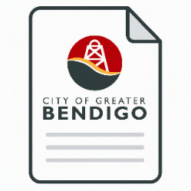 | The City of Greater Bendigo has written a draft plan.
 | The plan is called the Inclusive Greater Bendigo Foundation Action Plan.
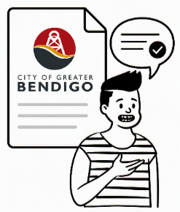 | We want your feedback.

About the plan
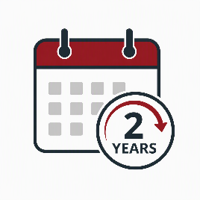 | The plan sets out actions for the next 2 years.
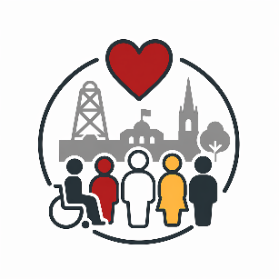 | These actions aim to make Greater Bendigo more inclusive.
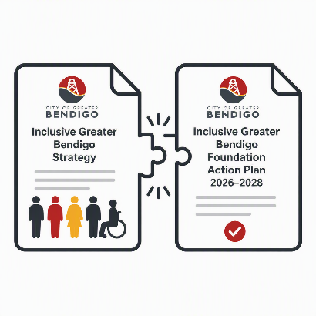 | The plan is part of the Inclusive Greater Bendigo Strategy.

Inclusion
Inclusion means more people can:
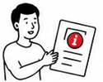 | Get information
 | Feel safe
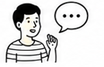 | Have a say
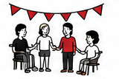 | Take part in community life

Making Greater Bendigo work for more people
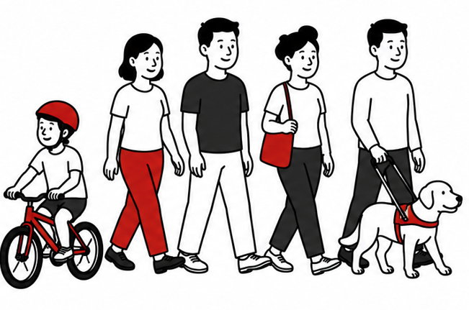 | People experience Greater Bendigo in different ways.
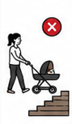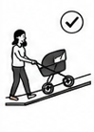 | What works well for one person may be harder for another person.
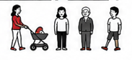 | We want everyday life to work well for more people.

Different life experiences
People have different experiences. A person may be:
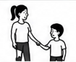 | A parent
 | A carer
 | A young person
 | An older person
 | A person with a disability
 | Part of a cultural or faith community
 | Someone who communicates differently
 | Live in town or live in a rural area
 | Many people are several of these things at the same time.

What is in the draft plan
The draft plan includes actions to:
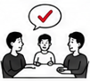 | Make better decisions for more people
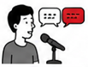 | Help people have a say
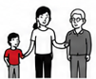 | Support people of all ages
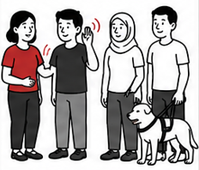 | Strengthen disability inclusion
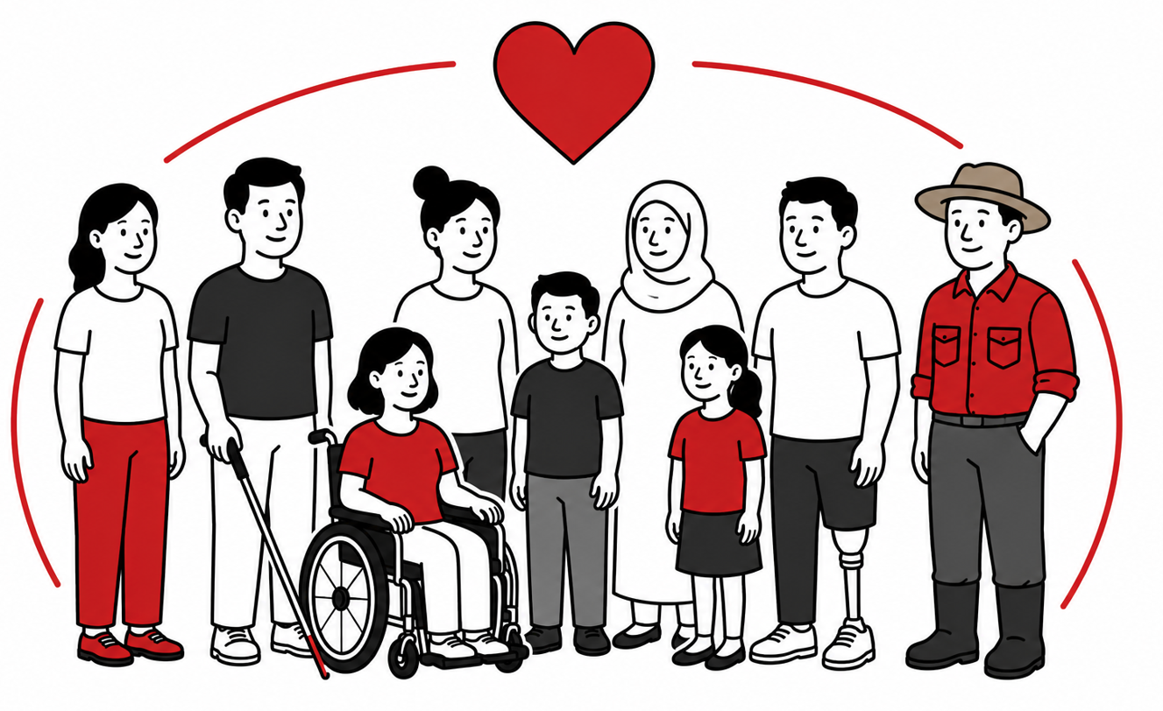 | Support diverse communities
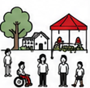 | Improve community events and spaces

Your feedback
We want to know:
 | Is the plan easy to understand?
 | Will it help people feel welcome and included?
 | Is anything missing?
 | Can anything be improved?

Give your feedback
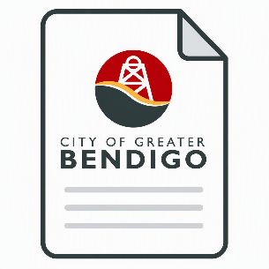 | You can complete the survey.
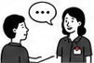 | You can contact the City if you need help.
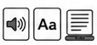 | You can ask for information in another format.

Contact us: communitypartnerships@bendigo.vic.gov.au

