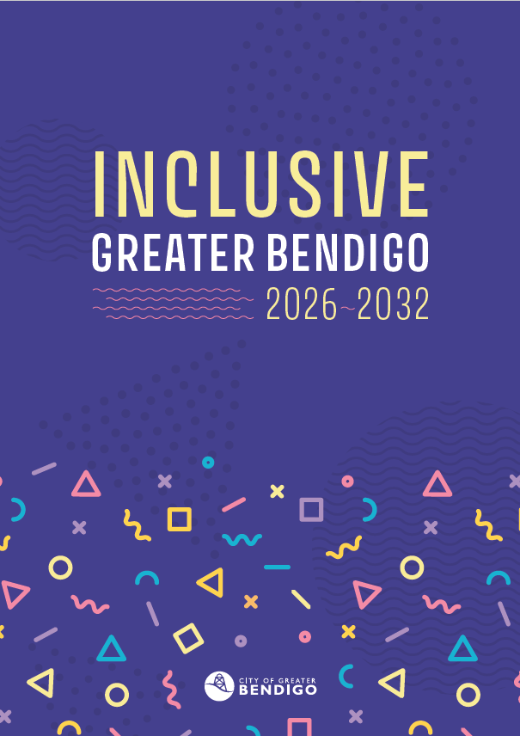

Inclusive Greater Bendigo
2026 – 2032

Community Vision
Greater Bendigo celebrates and respects our diverse and growing community. We aim to be welcoming, sustainable and flourishing. Walking hand-in-hand with our First Nations communities. Building on our heritage for a safe and happy future.

Acknowledgement of Country
We acknowledge the Dja Dja Wurrung and Taungurung Peoples as the Traditional Owners of the land on which the City of Greater Bendigo stands.
We pay our respects to leaders and Elders past, present and future, who hold the memories, the traditions, the culture and the hopes of all Dja Dja Wurrung and Taungurung Peoples. We thank them for sharing this land, recognise the pain and loss caused by that sharing, and hope that we can walk forward together in harmony and in the spirit of healing.
We also pay our respects to all Aboriginal and Torres Strait Islander peoples living in Greater Bendigo.

Our long-term vision
Greater Bendigo will be a place where everyday life works for more people.
This reflects the Community Vision for Greater Bendigo and describes how inclusion contributes to the kind of city the community wants to live in, now and into the future.
Differences in how people live, move, communicate and participate will be understood, expected and planned for.
Over time, decisions made by the City of Greater Bendigo (the City) will reduce barriers, making it easier for people to access services, use public spaces, feel safe and take part in community life.
This strategy starts with where we are heading.
The next section sets out the long-term priorities that guide how the City makes decisions and improves everyday life in Greater Bendigo. Later sections explain why these priorities matter, who they are for, and how different life experiences shape inclusion.

Strategic priorities
To support this long-term vision, the Inclusive Greater Bendigo Strategy sets out two long-term priorities.
These priorities describe how the City will make decisions and what people should experience in everyday life in Greater Bendigo. They stay consistent over time, with supporting actions delivered through two-year action plans, and annual Community Check-ins to report to the community on progress.

Priority 1: Better decisions for more people
This means making decisions that work for lots of different people – not just one ‘typical person’.
We do this by:
- seeking input from people with different life experiences
- thinking early about who might be left out
- changing how decisions are made from the beginning, avoiding the need to fix problems later
Priority 1 success looks like:
Our decisions are made for many kinds of people, with the understanding that people experience things differently.

Priority 2: Everyday life that feels safe, fair and welcoming
This means improving what people experience in their everyday lives in Greater Bendigo.
This includes:
- using the City’s services and facilities
- getting information
- being in public spaces
- taking part in community life
Priority 2 success looks like:
Our services and public places are designed to be easy and safe for everyone to use. Different needs are planned for from the start. When people do need help, it is easy to ask for. The strengths of our diverse community are recognised, valued and celebrated.

How we get there
This strategy sets the long-term direction for making Greater Bendigo more inclusive, fair and welcoming. It focuses on what matters most and how we take action over time.
The two priorities guide how the City makes decisions and plans services, places and activities. They stay the same over time.
We’ll turn these priorities into action through Inclusive Greater Bendigo Action Plans. Action Plans are updated every two years and focus on practical steps the City can take.
Each year, we’ll check in with the community to share how things are going.
Progress will be checked regularly. The City will learn and improve as the strategy continues, using community feedback to shape each action plan.
Making Greater Bendigo more inclusive is a shared responsibility. The City works with communities, organisations and partners to learn what works and make better decisions together.
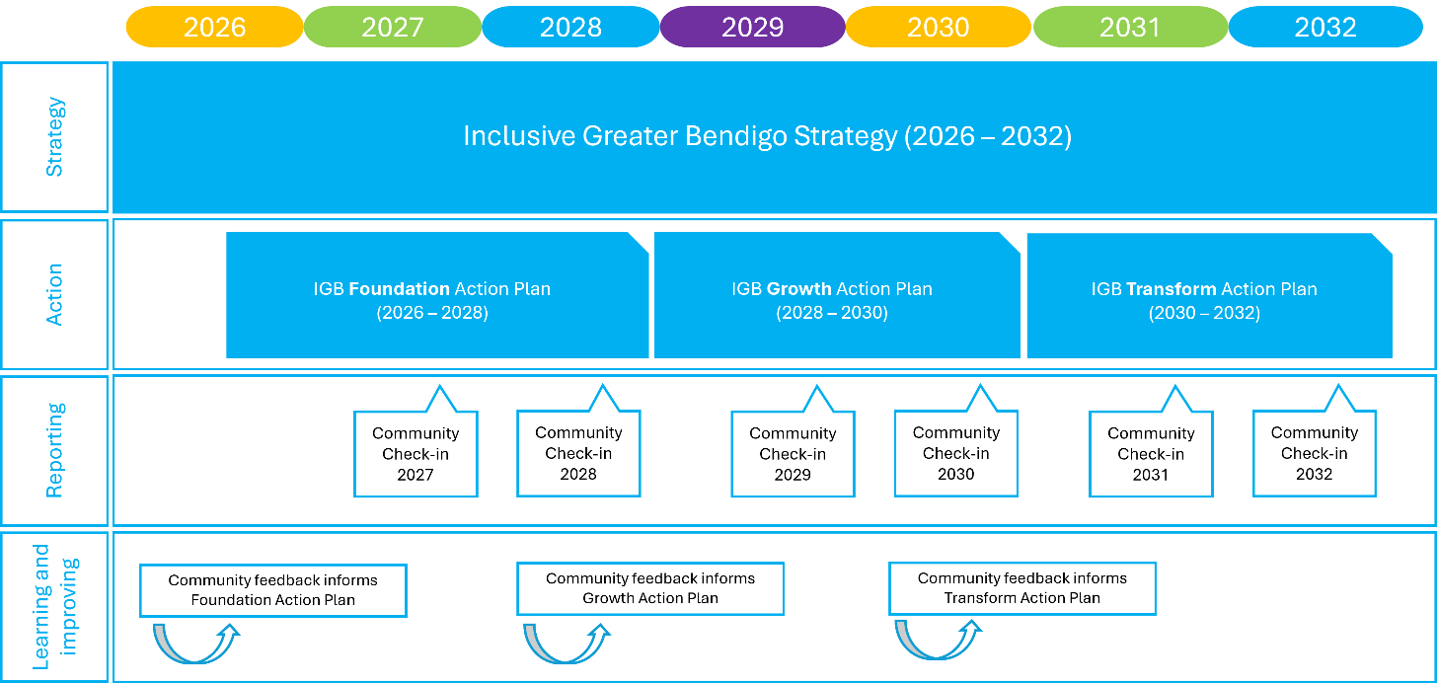

How we measure whether this strategy is working
We will assess progress using a combination of established Council Plan measures, decision-making evidence and community insight. We use different ways of checking progress because no single measure can tell the whole story.
This will include:
- Annual community check-ins
Community check-ins will provide qualitative insight into whether decisions and services are working as intended in people’s everyday lives, and highlight recurring barriers or unintended impacts that require further review or adjustment.
- Community-level indicators
Measures such as the Scanlon Index will be used to track broader community trends in wellbeing, belonging and social cohesion over time. This will help us understand the context in which decisions are being made and whether we need to adapt our approach.
- Equity Impact Assessments
EIAs will provide documented evidence that decisions are identifying who may be affected differently and considering inclusion impacts as part of good governance.
- Inclusive Delivery
Understanding how inclusion considerations and community satisfaction is tracking through the annual Community Satisfaction Survey.
Together, these measures help us understand whether decisions are being made more fairly, and whether those decisions are improving everyday experiences over time.

What Inclusive Greater Bendigo is
Inclusive Greater Bendigo is a six-year strategy that guides how the City plans, designs and delivers its work so everyday life works for more people.
It explains why the strategic priorities matter and how they respond to real lives in Greater Bendigo.
It turns our Community Vision into practical action by focusing on real lives.
This means thinking about who uses our roads, buildings, parks, services and information – and what makes those things easy or hard to use.
There is no single ‘typical person’. Everyone leads different lives, has different responsibilities, abilities, backgrounds and starting points.
This strategy helps us design with those differences in mind from the start. It sets a long-term direction.

Why this matters
Greater Bendigo is proud, welcoming and community-minded. But we all experience Greater Bendigo in different ways.
Everyday things like rules, forms, information, timelines and design choices can shape how people experience life. Thoughtful design with real lives in mind means that more people can take part.
Some people face extra difficulties that others may never have to think about. This can include getting into buildings, feeling safe in public places, understanding information, or travelling long distances to reach services.
Even people who do not face these added difficulties can feel stretched or unheard at times. It helps everyone when information is clear, and the city feels fair, reliable and easy to navigate.

How the City of Greater Bendigo has influence
The City does not control everything, but it does shape many parts of daily life in Greater Bendigo.
The City uses its influence in everyday ways – through systems, decisions and how work is done – to remove barriers and to support connection and belonging.
This includes how neighbourhoods are planned, how we deal with waste, how roads and public spaces are looked after, how services and information are delivered, how local jobs are created and maintained, and how arts, cultural and community events are planned and run.
Inclusion starts early – in plans, budgets and everyday decisions – long before a service is delivered or a space is built.
The City also works with community groups, local organisations and other systems like health, housing, education and employment. This helps improve outcomes and allows the City to speak up for positive change.

Who this strategy is for
This strategy is for everyone in Greater Bendigo.
We use examples of different life experiences to show where everyday systems can unintentionally exclude people, and how they can work better when real lives are considered.
We highlight the strengths people bring, and what the whole community misses out on when those strengths are overlooked.
People’s experiences overlap and change over time. Most people experience more than one difference or circumstance at once. When decisions are shaped around only one way of living, hurdles can build up. When people’s real-world lives are recognised, things tend to work better for everyone.
This does not mean taking things away or favouring one group over another. It means designing decisions that work for more people from the start.

Beyond the ‘typical person’

This section explains why designing for a ‘typical person’ doesn’t work in real life.
There is no single ‘typical person’. People lead different lives, have different responsibilities, abilities, backgrounds and starting points.
Many services, spaces and systems are designed as if everyone has the same time, health, energy and access.
These assumptions shape who finds it easy to take part and who faces barriers instead.
This section explains how everyday assumptions affect people at different stages of life and in different circumstances.

Culture, identity and communication

People come from different places
Many services are designed as if everyone already understands how things work locally.
People in Greater Bendigo come from many places and for many reasons. This includes people who were born overseas, people who have moved here for work, study or family, and people who arrived seeking safety.
They bring skills, ideas, businesses, cultural knowledge, faith traditions and global connections. These contributions enrich community life and support economic growth.
Challenges arise when people experience prejudice or exclusion, when everyday interactions feel unwelcoming or dismissive, or when overseas skills and experience are overlooked.
When different starting points are recognised, more people are able to settle, contribute and feel they belong.

People communicate differently
Information is often shared as if everyone reads, hears, speaks and understands in the same way.
In reality, people communicate in many ways. This includes Deaf people who use Auslan, people who speak languages other than English, people who find reading hard, people who are non-verbal, and people who rely on interpreters, captions, visuals, or communication devices.
This diversity strengthens families, workplaces and everyday community life.
When information is clear, accessible and flexible from the start, more people can take part.

People feel safe, recognised and respected in different ways
Many spaces and services are designed as if everyone feels safe, welcome and respected wherever they go. This is not always the case.
People move through Greater Bendigo differently depending on their experiences, identity, and how they are treated by others. Experiences of safety, recognition and respect are shaped by gender, sexuality and how difference is responded to in everyday settings.
What feels normal or easy for one person can feel stressful or unsafe for another.
Challenges arise when people experience prejudice or exclusion, when everyday interactions feel unwelcoming, dismissive or unsafe, or when people’s skills and experience are overlooked or not taken seriously.
Some people think carefully about where they go, what time of day they travel, or how visible they want to be. This can affect whether they use public spaces, attend events or access services.
These experiences are shaped by attitudes, past experiences and everyday design choices – such as how spaces are laid out, how concerns are handled, and whether people feel listened to and taken seriously.
When planning and services recognise that safety and belonging are experienced differently, more people are able to take part with confidence. This helps public spaces and services work better for everyone.

First Nations Peoples
Inclusive decision-making supports better outcomes for First Nations communities and strengthens Greater Bendigo as a whole.
Greater Bendigo is on Dja Dja Wurrung and Taungurung Country.
Aboriginal and Torres Strait Islander peoples in Greater Bendigo include the Traditional Owners of this land, as well as people from many other Nations who live and work here today.
Many services and systems were designed without First Nations Peoples having a say. Some of these decisions continue to shape everyday experiences now.
Like everyone, First Nations Peoples live diverse lives. There is no single experience or set of needs.
When planning and services recognise cultural responsibilities, family and community roles, and connection to Country, it becomes easier for people to take part, access services and contribute their knowledge and leadership.

Across the lifespan
Many services are designed around a narrow idea of adulthood focused on paid work, independence and flexibility.
The issue is not age itself, but assumptions about whose time, contribution and needs are valued. Assumptions about age can lead to people being overlooked, spoken for, or excluded from decision-making.
At every stage of life, people’s experiences differ and can change over time. They are shaped by culture, identity, how people communicate, where they live, and their life circumstances.

Children and families
Decisions are often made with assumptions about what families look like and how daily life works. This can include assuming that children live in one household, have stable care arrangements, and are supported by adults with predictable time, energy and resources.
Children in Greater Bendigo grow up in many different circumstances. Families take many forms. Some children live with extended family. Some move between households. Some do not live in family settings at all. There is no single ‘typical’ childhood or household.
Children bring strengths to community life in their own right. They notice whether places feel safe, welcoming and easy to move through. They express ideas, creativity and honesty.
Families and carers also strengthen communities. Through care, relationships, shared knowledge and everyday support, they help children grow. They support connection between generations and contribute to the wellbeing of neighbourhoods. For many people, caring for children sits alongside paid work, caring for others, managing health, study and daily responsibilities.
Challenges arise when education or care is hard to access, safe places to play and gather are limited, transport is difficult, or services are inflexible. These challenges affect both children and the people who support them.
When places, services and decisions are designed with children and the people who care for them in mind, it becomes easier to juggle daily life. Children are better supported to learn, play and feel safe, and families are better able to contribute to community life.

Young people
Young people bring energy, cultural expression, creativity and new perspectives to Greater Bendigo. They are active in sport, music, arts, volunteering, work, education and local projects. Many also provide care to family members, support friends, help neighbours and contribute to community life in ways that are not always seen or recognised.
Young people value opportunities to connect, express themselves, belong, lead and have a say in decisions that affect their lives, neighbourhoods and futures.
Challenges arise when transport options are limited, youth-friendly spaces are lacking, or young people do not feel heard or taken seriously. Stereotypes, judgement and being underestimated because of age can also affect confidence and participation.
When young people’s time, ideas and contributions are taken seriously, they are more able to participate, lead and stay connected. This strengthens communities now and helps build strong futures for Greater Bendigo.

Older people
Older people bring experience, skills, care and local knowledge to Greater Bendigo. They contribute through paid work, volunteering, caring for family and community members, sharing culture and knowledge, supporting local organisations and staying active in neighbourhood life.
Older people value opportunities to stay connected, participate, feel safe, share their knowledge and have choice and control over how they live. They want services, spaces and information that respect their independence, preferences and changing needs.
Challenges arise when spaces are not accessible or welcoming, information is hard to find or understand, transport options are limited, needs are assumed to be the same, or decisions are made without older people’s voices.
When services, spaces and decisions recognise older people’s experience and changing needs, they are better able to stay active, connected and independent. This benefits older people and strengthens neighbourhoods and community life.

Where we live
Where people live in Greater Bendigo can shape their everyday experiences.
Access to transport, services, jobs, safe public spaces and community facilities is not the same in every neighbourhood. These differences are shaped by planning decisions, infrastructure, investment and access to services over time.

Neighbourhoods and access
Every neighbourhood has strengths, shaped by the people who live there, their relationships, and the ways they support one another. At the same time, every neighbourhood is shaped by everyday things like transport, services, housing and local spaces.
In some neighbourhoods, everyday barriers are greater. Services may be further away, public transport options limited, housing options fewer, or local spaces may not feel safe, welcoming or well-maintained.
These challenges are not caused by the people who live there. Neighbourhoods are often rich in knowledge, connection and care, but stereotypes about place can overlook these strengths and lead people to be underestimated or dismissed.
Where disadvantage is concentrated, it often overlaps with other life circumstances such as low income, disability, caring responsibilities, cultural background or health challenges. When barriers stack in this way, everyday tasks can take more time, effort and cost.
Designing services and decisions without considering place can widen these gaps. Designing with neighbourhood differences in mind can help reduce them and build on the strengths that already exist in local communities.

Place and distance
Greater Bendigo’s rural townships and surrounding farming areas are a defining strength of the municipality.
Rural communities are places of connection, resourcefulness and strong local identity. People contribute through farming, small businesses, volunteering, caring for neighbours, local events and deep connections to land and place. These townships play an important role in Greater Bendigo’s social, cultural and economic life.
At the same time, distance shapes daily life. People in rural areas often travel further to access services, education, healthcare, employment and social activities. Transport options, service availability and digital access can vary between townships.
When services are flexible, well connected and designed with rural life in mind, people in townships are better supported to participate, contribute and stay connected.

Life circumstances
Many services are designed as if people have stable health, energy, income, housing and time. But people’s lives are not all the same. For some people, life includes sudden or unexpected changes. For others, difference is ongoing and shapes daily life.

Disability
People with disability are active in every part of life in Greater Bendigo; as workers, students, carers, parents, artists, volunteers and leaders. Disability is part of human diversity, not a problem to be fixed.
Disability can be visible or invisible, lifelong or acquired, consistent or fluctuating. It can include physical, sensory, cognitive and neurodivergent experiences.
Some people move in and out of disability across their lives due to injury, chronic illness, ageing or changes in mental health. These experiences are not always obvious to others.
Challenges arise when buildings, transport, digital systems or services are not designed to be accessible, flexible or welcoming, or where capability and independence is underestimated. These difficulties are created by assumptions and design choices, not by disability itself.
When access is built in from the start – step-free spaces, clear information, predictable processes, options for quiet or low-sensory environments, and multiple ways to communicate and take part – more people are able to participate with confidence. These design choices often make everyday life easier for many others as well.

Care
Many people support family members, friends or neighbours at different times of life because of disability, illness, ageing or mental ill‑health. This care is essential and often unseen.
Providing care involves coordination, advocacy and emotional labour. It is commonly carried out alongside paid work, study, managing health needs and maintaining relationships.
Challenges arise when services, systems and decisions are designed around assumptions of unlimited time, flexibility or individual independence. These pressures are created by how systems are designed, not by caring itself.
When care is recognised, supported and considered in decision‑making, it becomes easier for people who provide care to stay connected, participate and contribute to community life.

Health, wellbeing, financial or housing instability
At different times, people experience circumstances that make everyday participation harder. This includes living with acute or chronic health conditions, mental ill-health, low income, unemployment, housing insecurity, homelessness or family violence.
These experiences may be temporary or ongoing, and often overlap with caring responsibilities, disability, age, gender, culture or location. They are not always visible, but they shape how people engage with work, services and community life.
When services, spaces and opportunities to connect are affordable, coordinated, safe and flexible – and designed around real lives rather than ideal conditions – people are better able to stay connected, participate, find stability and share their strengths with everyone.

What this means for how we work
This Strategy is about recognising strengths and making sure that decisions and designs allow those strengths to be shared.
The biggest impacts on inclusion happen early, through assumptions built into plans, policies, budgets and everyday decisions.
What this means for how we work is that inclusion is part of normal decision-making. It is considered early, consistently and deliberately, so that services, spaces, engagement and activities that happen later work for more people, without needing extra fixes.

